**Programming Challenge #2 (25 points) – Due 3/21 on or before 10:00pm**

**Objectives**: **for loop, and if/else if** statements

|  |
| --- |
| **Important instructions:**   * *All programs must include comments at the top of your program: your name,* the class name (CSIT 575)*, program name and* ***the program description (purpose of the program).*** * *Copy and paste your* ***program code*** *and* ***output*** *in Part B of each program. Note: Use snipping tool to snip the output.* * *Once it is done, save and submit this word file via Canvas.* |

**CharacterCount.cpp**

Write a program counts the number of letters, digits, spaces and symbols in the first 30 input characters.

***Input validation:*** *the program must handle the singular or plural of the correct answers.*

**Hints:** use <cctype> header; use cin.get()

**Sample run 1**

Enter your text: 1234 567 !@#$%^ cvbnm,./ 45678

Input contained:

5 letters.

12 digits.

9 symbols.

4 spaces.

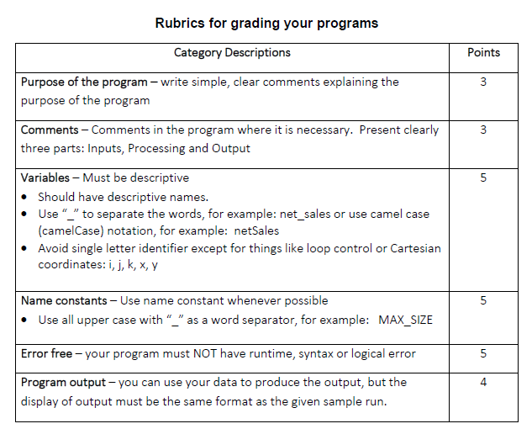

**Part B: Copy and paste your program (source) code and the outputs after this line.**

++++++++++++++++++++++++++++++++++++++++++++++++++++++++++++++++++++

//Erik Gonzalez

//COSCI 575

//CharacterCount.cpp

//This program counts the number of letters, digits, spaces and symbols in the first 30 input characters.

#include <iostream>

#include <cctype>

using namespace std;

int main()

{

char userInput;

int letters = 0;

int digits = 0;

int symbols = 0;

int spaces = 0;

cout << "Enter your text: ";

for (int i = 1; i <= 30; i++)

{

cin.get(userInput); //input

if (isalpha(userInput))

letters++;

else if (isdigit(userInput))

digits++;

else if (isspace(userInput))

spaces++;

else

symbols++;

}

cout << "Input contained: \n";

//Checks if anything in the input is equal to one to use correct grammar and also outputs

if (letters == 1)

cout << "\n" << letters << " letter." << endl;

else

cout << "\n"<< letters << " letters." << endl;

if (digits == 1)

cout << digits << " digit." << endl;

else

cout << digits << " digits." << endl;

if (spaces == 1)

cout << spaces << " space." << endl;

else

cout << spaces << " spaces." << endl;

if (symbols == 1)

cout << symbols << " symbol." << endl;

else

cout << symbols << " symbols." << endl;

system("pause");

return 0;

}

**Output 1:**

Enter your text: yyyyyyyyyy 43652345 ^!$&!#$ 1488 648289

Input contained:

10 letters.

10 digits.

3 spaces.

7 symbols.

Press any key to continue . . .

**Output 2:**

Enter your text: &@T$&!@$*&@#& 324878 @!*$&*&

Input contained:

1 letter.

6 digits.

7 spaces.

16 symbols.

Press any key to continue . . .

**Output 3:**

Enter your text: 348723847918*&*(&@*(!&&$@huasfdf(&@&)$789181

Input contained:

5 letters.

12 digits.

0 spaces.

13 symbols.

Press any key to continue . . .